NCA Functional Specifications

# Overview

NCA is an app that helps the user to save their password securely. An NCA password will be created the first time

NCA is the name of the solution. It stands for Nao Can Assistant（脑残助理）. The actual app name shall be changed for marketing purposes（钥匙圈）.

# Detailed Functionalities

## Initial View

Only appears when the user initially launches the product. The initial view provides the user ability to set NCA password, which is required later when accessing NCA. It also requires the user to enter a security question and a security answer, which will be used to recover NCA password.

The initial view contains 4 text fields:

|  |  |  |
| --- | --- | --- |
| Name | Required? | Input Check |
| Password | Yes | Cannot be empty |
| Password Confirmation | Yes | Matches Password |
| Security Question | Yes | Cannot be empty |
| Security Answer | Yes | Cannot be empty |

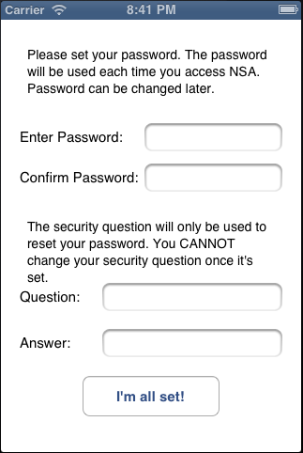

## Main View

The Main View displays all saved items. It contains 2 tool bars and a UITableView.

* Top Tool Bar (Navigation bar)
* Add button: Click this button presents the Add View.
* Bottom Tool Bar
* Settings button: Click this button presents the Settings View.
* The View

The actual view is a table view that displays all items by title and notes.

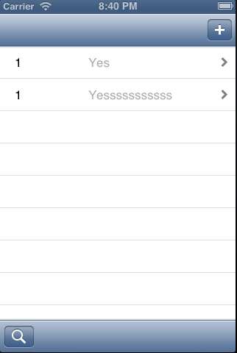

## Add View

The Add View is used to add new items. It contains a navigation bar and a UITableView.

* Navigation Bar
* Done button: Click this button will start the process of Validation | Insert New Item.
* Cancel button: Click this button will dismiss the Add View.
* The View

The UITableView contains labels and text fields. Cell creations and text field validations are based on *3.1 Password*.

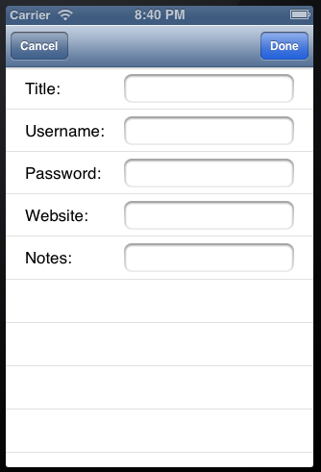

## Detail View

The Detail View displays all information about selected item. It contains a navigation bar and a UITableView.

* Navigation Bar
* Back button: Automatically created by the navigation controller. Click this button will dismiss the Detail View and present the previous view.
* Edit button: Click this button will bring up the Edit View, with information populated by current item.
* The View

The UITableView contains labels. Cell creations are based on *3.1 Password*.

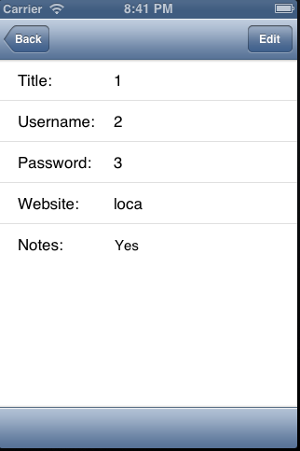

## Edit View

The Edit View allows user to edit the item which is displayed in the Detail View. It contains a navigation bar and a UITableView.

* Navigation Bar
* Back button: Automatically created by the navigation controller. Click this button will dismiss the Edit View and present the Detail view.
* The View

The UITableView contains labels and text fields. Cell creations and text field validations are based on *3.1 Password*.

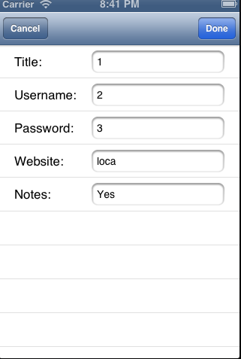

## Lock Views

### Lock View

Default view whenever the app come to foreground.

Lock View has 1 text field where user is asked to enter NCA password.

* On correct input, Lock View will disappear and the top view will present. In case where the top view has been released, Main View will be displayed.
* On incorrect input, Lock View will show messages to inform the user. After 10 consecutive incorrect inputs, NCA will be locked down, and the user then can only enter password once per 24 hours afterwards.

The Lock View has 1 rectangular button (“forget password?”). Clicking this button will bring up Forgot Password View

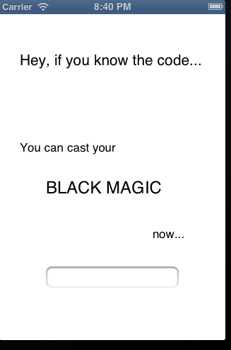

### Forgot Password View

Validation purposed view. The user can reset NCA password by entering correct security answer.

The security questions will be displayed in this view.

Forgot Password View contains 1 text field where user is asked to enter the answer to security question.

* On correct input, Reset Password View appears, the user can then change NCA password.
* On incorrect input, alert will be sent. After 10 consecutive incorrect inputs, NCA will be locked down, and the user then can only enter security answer once per 24 hours afterwards.

### Reset Password View

A simple view with 2 text fields so that the user can reset NCA password.

|  |  |  |
| --- | --- | --- |
| Name | Required? | Input Check |
| Password | Yes | Cannot be empty |
| Password Confirmation | Yes | Matches Password |

## Settings View

# Data Models

## Password

|  |  |  |
| --- | --- | --- |
| Column | Type | NULLABLE? |
| Title | NSString | NO |
| Username | NSString | YES |
| Password | NSString | NO |
| Website | NSString | YES |
| Notes | NSString | YES |

# Security Concerns

# Unit Tests